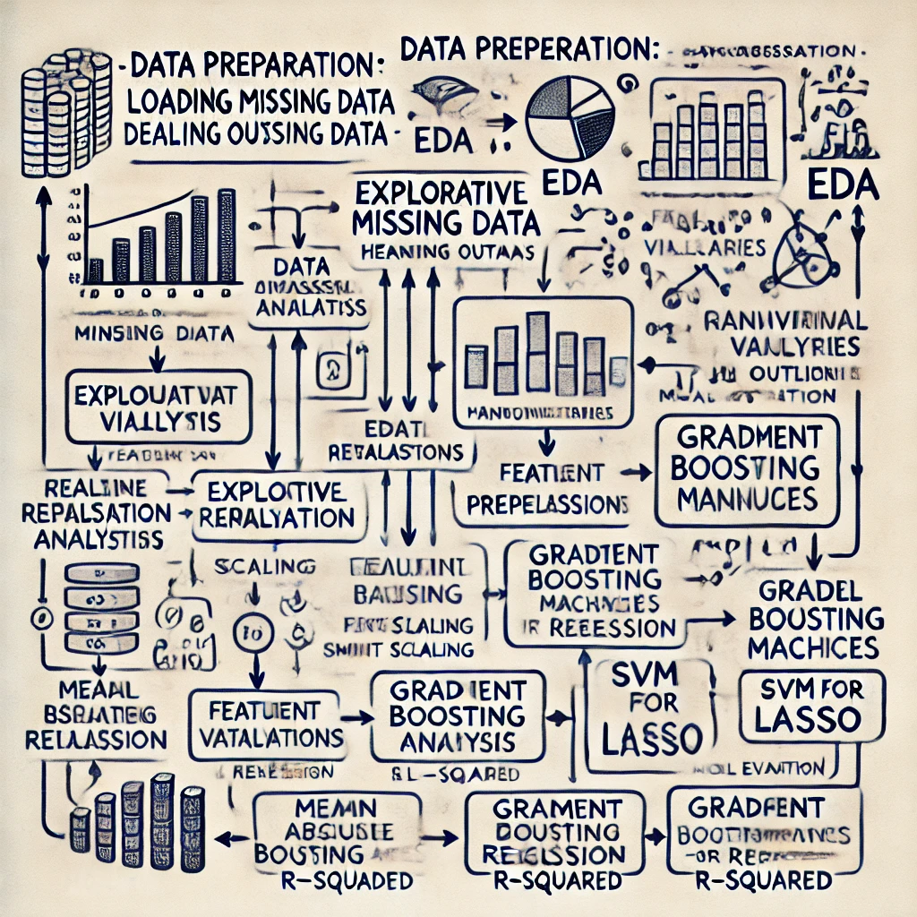

|  |
| --- |
|  |
| Predicting House Prices:  Leveraging Machine Learning for Real Estate Valuation |
| |  |  | | --- | --- | |  | Data Science | |

**Abstract**

In today’s dynamic real estate market, accurately predicting house prices is critical for buyers, sellers, and investors to make informed decisions. This project leverages machine learning to develop a predictive model using historical data, including features like square footage, number of rooms, location, and neighborhood characteristics. By addressing challenges like non-linear relationships and feature variability, the model delivers data-driven insights for property valuation.

Machine learning models, including Linear Regression, Decision Trees, and advanced ensemble methods such as Gradient Boosting, are employed. Evaluation metrics like Root Mean Squared Error (RMSE) and R² score validate their performance. The results demonstrate that these algorithms effectively predict prices, enhancing transparency and efficiency in the real estate market. This approach empowers stakeholders with fair valuations, streamlined transactions, and actionable insights for better decision-making.

**Introduction**

House price prediction is a pivotal task in the real estate market, influencing decisions made by buyers, sellers, and investors. Property values depend on multiple factors, such as physical attributes (e.g., size, age, and number of rooms), location-specific characteristics (e.g., neighborhood amenities and proximity to key areas), and market conditions. Traditional valuation methods, often reliant on subjective judgment, are prone to inaccuracies and inconsistencies, leading to suboptimal pricing and potential financial losses.

The advent of machine learning provides a robust alternative to traditional valuation techniques. Machine learning models can analyze large datasets, identify complex patterns, and predict property prices with greater accuracy. Unlike traditional methods, these models excel at capturing non-linear relationships and interactions among features, making them highly suitable for real estate datasets.

This project aims to build a machine learning-based system for predicting house prices using a comprehensive dataset. The workflow includes data preprocessing, feature engineering, and applying algorithms like Linear Regression, Decision Trees, and Gradient Boosting. The models’ performances are evaluated using RMSE and R², ensuring reliability and applicability.

By leveraging data-driven models, this project contributes to market transparency, fair pricing, and efficient decision-making processes in real estate. The outcomes not only enable stakeholders to set competitive and fair prices but also enhance the overall efficiency of the real estate transaction ecosystem.

**Problem Statement**

Accurately predicting house prices is a significant challenge in the real estate market due to the variability in property values caused by both tangible factors, such as size and condition, and intangible ones, such as location desirability and market trends. Traditional valuation methods often depend on subjective human judgment, leading to inconsistencies, inaccuracies, and potential financial losses.

The unpredictability of real estate prices, influenced by economic conditions, neighborhood development, and seasonal trends, makes it difficult for buyers, sellers, and investors to make informed decisions. Without a standardized, data-driven tool, individuals must rely on outdated or incomplete methods, resulting in suboptimal pricing and missed opportunities.

**Proposed Solution**

To overcome the limitations of traditional property valuation methods, this project proposes a machine learning-based predictive system that utilizes historical data to estimate house prices. By incorporating advanced algorithms, the model is designed to analyze the relationships between property attributes and their respective market prices.

Key steps in the proposed solution include:

1. **Data Preprocessing**: Cleaning and preparing the data by handling missing values, addressing outliers, and encoding categorical features.
2. **Feature Engineering**: Identifying and transforming influential features to enhance model accuracy.
3. **Model Training and Evaluation**: Implementing multiple machine learning algorithms and comparing their performance using metrics like RMSE and R².

This approach not only ensures accurate and reliable predictions but also enhances the decision-making process by providing actionable insights to stakeholders in the real estate market.

**Summary**

This project focuses on building a machine learning-based system for predicting house prices using a structured dataset comprising key features like square footage, year built, number of bedrooms and bathrooms, and neighborhood. By leveraging historical data, the aim is to create an accurate and reliable predictive model capable of identifying patterns and relationships that influence property values.

The project involves several stages, including data preprocessing, feature engineering, and model development using machine learning techniques such as Linear Regression, Decision Trees, and Gradient Boosting. Performance is evaluated using metrics like RMSE and R², ensuring the model's accuracy and applicability.

The findings from this project provide valuable insights into real estate pricing and demonstrate the utility of data-driven models in delivering consistent and transparent property valuations. This solution empowers stakeholders, such as buyers, sellers, and investors, to make better-informed decisions, streamlining the real estate transaction process.

**Scope**

The scope of this project encompasses the following key stages and objectives:

1. Data Collection: Utilize a structured real estate dataset containing historical house prices and attributes, including neighborhood, size, and year built.
2. Data Preprocessing: Address missing values, remove outliers, and encode categorical variables to prepare the dataset for machine learning. Normalize and scale numerical features to improve model performance.
3. Model Development: Implement and compare multiple machine learning algorithms, including Linear Regression, Decision Trees, and Gradient Boosting, to identify the best-performing model for house price prediction.
4. Model Evaluation: Use robust evaluation metrics like RMSE and R² to assess model accuracy and reliability.

By adhering to these stages, the project ensures a comprehensive approach to house price prediction, resulting in a reliable and scalable solution for stakeholders.

**Literature Survey**

The problem of predicting house prices has attracted considerable attention in fields like data science, economics, and machine learning. This section reviews key approaches to house price prediction and their relative effectiveness.

1. **Traditional Approaches: Linear and Multiple Linear Regression**

Linear regression has been a baseline model for house price prediction due to its simplicity and interpretability.

Studies, such as "Predicting House Prices with Multiple Linear Regression" (2015), demonstrate that while linear regression can handle smaller datasets effectively, it struggles with complex, non-linear relationships.

Limitations: Linear models assume linear relationships between features and the target variable, making them unsuitable for datasets with intricate dependencies.

1. **Machine Learning Approaches: Decision Trees and Random Forests**

Machine learning models improve accuracy by capturing non-linear relationships and interactions.

Research, such as "Using Random Forests for House Price Prediction" (2017), shows that Random Forests outperform linear regression models, especially with mixed numerical and categorical variables. They also excel at feature importance and mitigating overfitting.

Strength: Decision trees offer interpretability, while Random Forests enhance accuracy through model averaging.

Limitation: Computationally intensive and prone to overfitting without proper hyperparameter tuning.

1. **Advanced Ensemble Methods: Gradient Boosting and XGBoost**

Gradient boosting methods, such as XGBoost, have become a gold standard for structured data due to their high predictive accuracy.

Studies, such as "Predicting Real Estate Prices Using XGBoost" (2019), highlight XGBoost’s superior performance in reducing overfitting and handling outliers.

Strength: High accuracy, robust handling of outliers, and modeling complex interactions.

Limitation: Requires careful parameter tuning, which can increase computational cost.

**Insights from Literature**

* Traditional regression models are suitable for small, simple datasets but fall short with complex data.
* Machine learning models like Random Forests and Gradient Boosting improve accuracy by addressing non-linear relationships and feature interactions.
* Ensemble methods, particularly XGBoost, are highly effective for large datasets, making them well-suited for real estate price prediction.

This project builds on these insights, emphasizing a comprehensive workflow from preprocessing to model evaluation, ensuring real-world applicability.

**Research Gap**

Despite advancements in predictive modeling, many studies primarily focus on algorithm performance while neglecting practical challenges such as data preprocessing, feature engineering, and real-world deployment. Additionally, most existing research overlooks the inclusion of external factors like economic trends, proximity to amenities, or market fluctuations, which significantly impact property valuations. This project aims to address these gaps by:

1. Emphasizing a comprehensive data preparation workflow.
2. Incorporating robust evaluation methods to assess real-world applicability.
3. Exploring feature interactions to improve predictive accuracy.

**Methodology**

The project follows a systematic approach to building an accurate house price prediction model:

1. **Data Preparation:**

* Loading a structured dataset containing key features like square footage, number of rooms, and location.
* Handling missing values and outliers using statistical methods.
* Encoding categorical features (e.g., neighborhood) and scaling numerical data.

1. **Exploratory Data Analysis (EDA):**

* Conducting univariate and bivariate analyses to understand data distributions and relationships.
* Creating visualizations like scatter plots and correlation heatmaps.

1. **Feature Engineering:**

* Selecting and transforming key features based on their significance in influencing house prices.
* Addressing multicollinearity among predictors.

1. **Model Implementation:**

* Training models like Linear Regression, Decision Trees, and Gradient Boosting.
* Performing hyperparameter tuning to optimize model performance.

1. **Evaluation:**

Assessing model accuracy using RMSE, MAE, and R².

Comparing results across multiple algorithms.

**Dataset**

A significant challenge in building a reliable predictive model is acquiring good quality data. For housing price prediction, we need comprehensive and diverse data that includes features such as house attributes, historical sale prices, and market conditions. However, obtaining such high-quality, labelled data can be difficult.

House price prediction is a key area of research in real estate analytics, with applications in property valuation, investment, and market trend analysis. For this proof of concept (PoC), we'll focus on using the available arms house price dataset, which might have a smaller set of data points but can still be useful for building an initial model.

We have chosen the arms house price dataset because it contains critical features such as house size, neighbourhood information, the number of bedrooms, and historical sales data, making it a reasonable fit for predicting house prices in our target application. The dataset provides a variety of features that are common in many real estate datasets, making it a good start for our model development.

### ****Data Dictionary****

|  |  |  |
| --- | --- | --- |
| Feature | Data Type | Description |
| SquareFeet | Numerical | Total area of the house in square feet, a primary determinant of property value. |
| YearBuilt | Numerical | The year the house was built, indicative of its age and condition. |
| Bedrooms | Numerical | Number of bedrooms in the house, indicating living capacity. |
| Bathrooms | Numerical | Number of bathrooms, including partial bathroom. |
| Neighborhood | Categorical | The location of the property, significantly influencing price. |
| Price | Numerical | The target variable, representing the sale price of the house. |

**Data Ingestion**

* The dataset is imported into the environment using libraries like Pandas for data manipulation.
* Verified the integrity and structure of the dataset.

**Basic Dataset Info:**

<class 'pandas.core.frame.DataFrame'>

RangeIndex: 50000 entries, 0 to 49999

Data columns (total 6 columns):

# Column Non-Null Count Dtype

--- ------ -------------- -----

0 SquareFeet 50000 non-null int64

1 Bedrooms 50000 non-null int64

2 Bathrooms 50000 non-null int64

3 Neighborhood 50000 non-null object

4 YearBuilt 50000 non-null int64

5 Price 50000 non-null float64

dtypes: float64(1), int64(4), object(1)

memory usage: 2.3+ MB

**Shape of the Dataset:** (50000, 6)

**Sample Dataset:**

|  |  |  |  |  |  |  |
| --- | --- | --- | --- | --- | --- | --- |
|  | SquareFeet | Bedrooms | Bathrooms | Neighbourhood | YearBuilt | Price |
| 30438 | 1408 | 5 | 1 | Rural | 2005 | 58263.07 |

**Top records of Dataset:**

|  |  |  |  |  |  |  |
| --- | --- | --- | --- | --- | --- | --- |
|  | SquareFeet | Bedrooms | Bathrooms | Neighbourhood | YearBuilt | Price |
| 0 | 2126 | 4 | 1 | Rural | 1969 | 215355.28 |
| 1 | 2459 | 3 | 2 | Rural | 1980 | 195014.22 |
| 2 | 1860 | 2 | 1 | Suburb | 1970 | 306891.01 |
| 3 | 2294 | 2 | 1 | Urban | 1996 | 206786.78 |
| 4 | 2130 | 5 | 2 | Suburb | 2001 | 272436.23 |

**Bottom records of Dataset:**

|  |  |  |  |  |  |  |
| --- | --- | --- | --- | --- | --- | --- |
|  | SquareFeet | Bedrooms | Bathrooms | Neighbourhood | YearBuilt | Price |
| 49995 | 1282 | 5 | 3 | Rural | 1975 | 100080.86 |
| 49996 | 2854 | 2 | 2 | Suburb | 1988 | 374507.65 |
| 49997 | 2979 | 5 | 3 | Suburb | 1962 | 384110.55 |
| 49998 | 2596 | 5 | 2 | Rural | 1984 | 380512.68 |
| 49999 | 1572 | 5 | 3 | Rural | 2011 | 221618.58 |

**Dataset Characteristics**

1. *Shape of Dataset:*
   * Total Records: 50,000
   * Total Features: 6
2. *Data Types:*
   * Numerical Columns: SquareFeet, YearBuilt, Bedrooms, Bathrooms, Price
   * Categorical Columns: Neighborhood
3. *Unique Values:*
   * Neighborhood: 3 unique values (Suburb, Rural, Urban)
4. *Target Variable (Price):*
   * Distribution: Normal distribution, with most homes priced below the mean but a few significantly expensive properties.

**Summary Statistics:**

Generated summary statistics for numerical and categorical features to understand distributions and identify anomalies.

|  |  |  |  |  |  |  |  |  |
| --- | --- | --- | --- | --- | --- | --- | --- | --- |
|  | count | mean | std | min | 25% | 50% | 75% | max |
| SquareFeet | 50000.0 | 2006.370 | 575.51 | 1000.00 | 1513.00 | 2007.0 | 2506.00 | 2999.00 |
| Bedrooms | 50000.0 | 3.49 | 1.11 | 2.00 | 3.00 | 3.00 | 4.00 | 5.00 |
| Bathrooms | 50000.0 | 1.99 | 0.81 | 1.00 | 1.00 | 2.00 | 3.00 | 3.00 |
| YearBuilt | 50000.0 | 1985.40 | 20.71 | 1950.00 | 1967.0 | 1985.00 | 2003.00 | 2021.00 |
| Price | 50000.0 | 224827 | 76141 | -36588 | 169955 | 225052 | 279373 | 492195 |

|  |  |  |  |  |
| --- | --- | --- | --- | --- |
|  | count | unique | top | freq |
| Neighborhood | 50000 | 3 | Suburb | 16721 |

**1. Data Cleaning and Preparation**

* *Missing Values:*

After thoroughly inspecting the dataset, no missing values were found in any of the features. This was an advantage, as it eliminated the need for imputation or handling null values.

* *Outlier Removal:*

Outliers detected during preprocessing were removed using IQR thresholds to ensure that the dataset remained representative of typical house prices and characteristics.

* *Handling Categorical Data:*

The Neighborhood column, a categorical feature, was encoded using Ordinal Encoding to transform it into numerical values suitable for machine learning models. This step ensured that the model could process the categorical data effectively without losing valuable information.

**Missing Values:** Verified there were no missing values in any feature columns.

SquareFeet 0

Bedrooms 0

Bathrooms 0

Neighborhood 0

YearBuilt 0

Price 0

**Outliers detected using IQR:** extreme values based on statistical thresholds (e.g., beyond 1.5 * IQR).

Outliners are:(59, 6)

**Sample of Outliers detected using IQR:**

|  |  |  |  |  |  |  |
| --- | --- | --- | --- | --- | --- | --- |
|  | SquareFeet | Bedrooms | Bathrooms | Neighborhood | YearBuilt | Price |
| 1266 | 1024 | 2 | 2 | Urban | 2006 | -24715.24 |
| 2310 | 1036 | 4 | 1 | Suburb | 1983 | -7550.50 |
| 2845 | 2999 | 5 | 2 | Urban | 1999 | 461502.01 |
| 3285 | 2985 | 5 | 1 | Rural | 1961 | 456959.80 |
| 3357 | 2928 | 3 | 3 | Suburb | 1962 | 457902.67 |

**After removing outliners:** Outliers were removed to ensure they did not distort model performance.

**Result:** Reduced dataset size from 50,000 to 49,941 records. **Descriptive Statistics:**

|  |  |  |  |  |  |  |  |  |
| --- | --- | --- | --- | --- | --- | --- | --- | --- |
|  | count | mean | std | min | 25% | 50% | 75% | max |
| SquareFeet | 49941 | 2006.36 | 575.05 | 1000.00 | 1513.00 | 2007.00 | 2505.00 | 2999.00 |
| Bedrooms | 49941 | 3.49 | 1.11 | 2.00 | 3.00 | 3.00 | 4.00 | 5.00 |
| Bathrooms | 49941 | 1.99 | 0.81 | 1.00 | 1.00 | 2.00 | 3.00 | 3.00 |
| YearBuilt | 49941 | 1985.40 | 20.72 | 1950.00 | 1967.00 | 1985.00 | 2003.00 | 2021.00 |
| Price | 49941 | 224822.91 | 75762.86 | 6124.03 | 170000.83 | 225051.07 | 279320.16 | 443335.49 |

|  |  |  |  |  |
| --- | --- | --- | --- | --- |
|  | count | unique | top | freq |
| Neighborhood | 49941 | 3 | Suburb | 16700 |

Examples:

SquareFootage: Mean = 2006 sq. ft., Standard Deviation = 575 sq. ft.

YearBuilt: Mean = 1985, Range = 1950 to 2021.

**Data Visualization:**

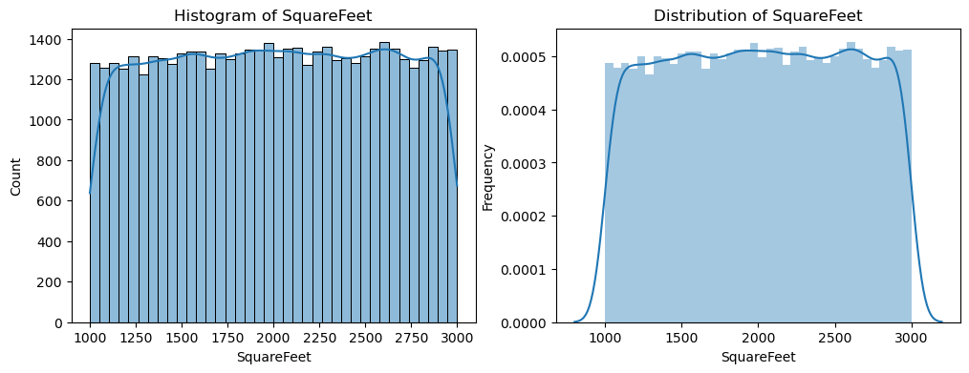

**SquareFeet:** Normally distributed with a peak around 2,000 sq. ft., representing average-sized homes.

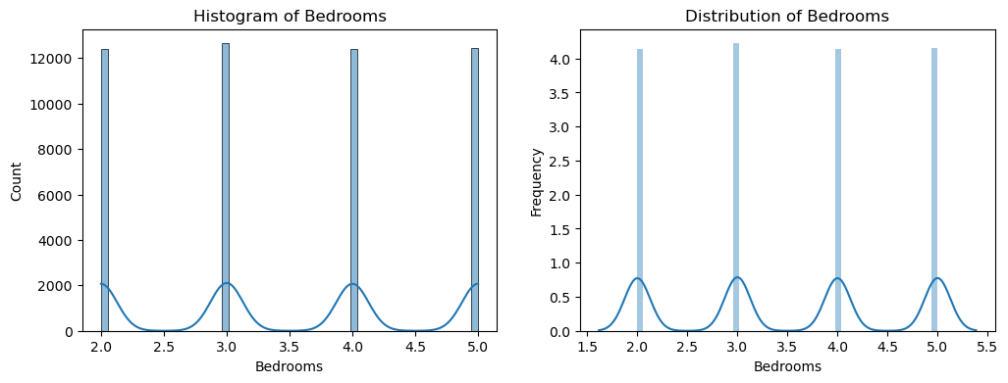

**Number of Bedrooms**: Multimodal distribution with peaks at 2, 3, 4, and 5 bedrooms, showing distinct categories like smaller homes, typical family homes, and larger homes.

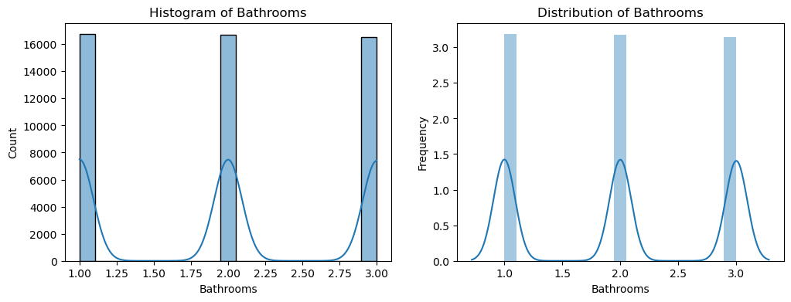

**Number of Bathrooms**: Multimodal distribution with peaks at 1, 2, and 3 bathrooms, indicating common bathroom configurations.

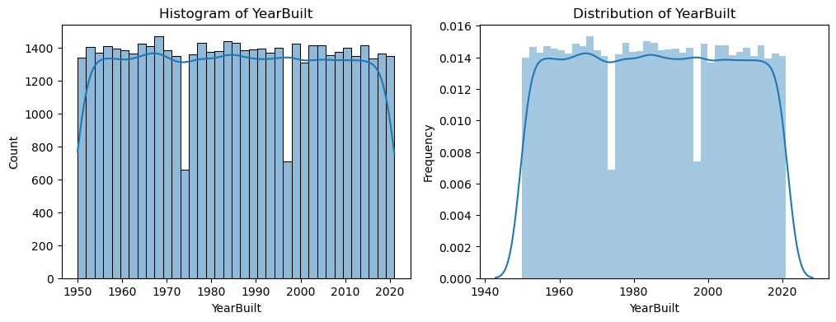

**YearBuilt**: Multimodal distribution with peaks in 1960, 1980, 1990, and 2000, suggesting distinct housing development periods.

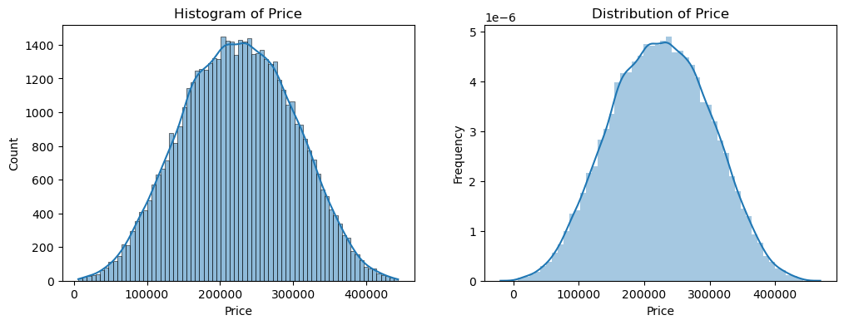

**House Prices**: Right-skewed distribution, with most homes priced lower and a few expensive homes pulling the prices up.

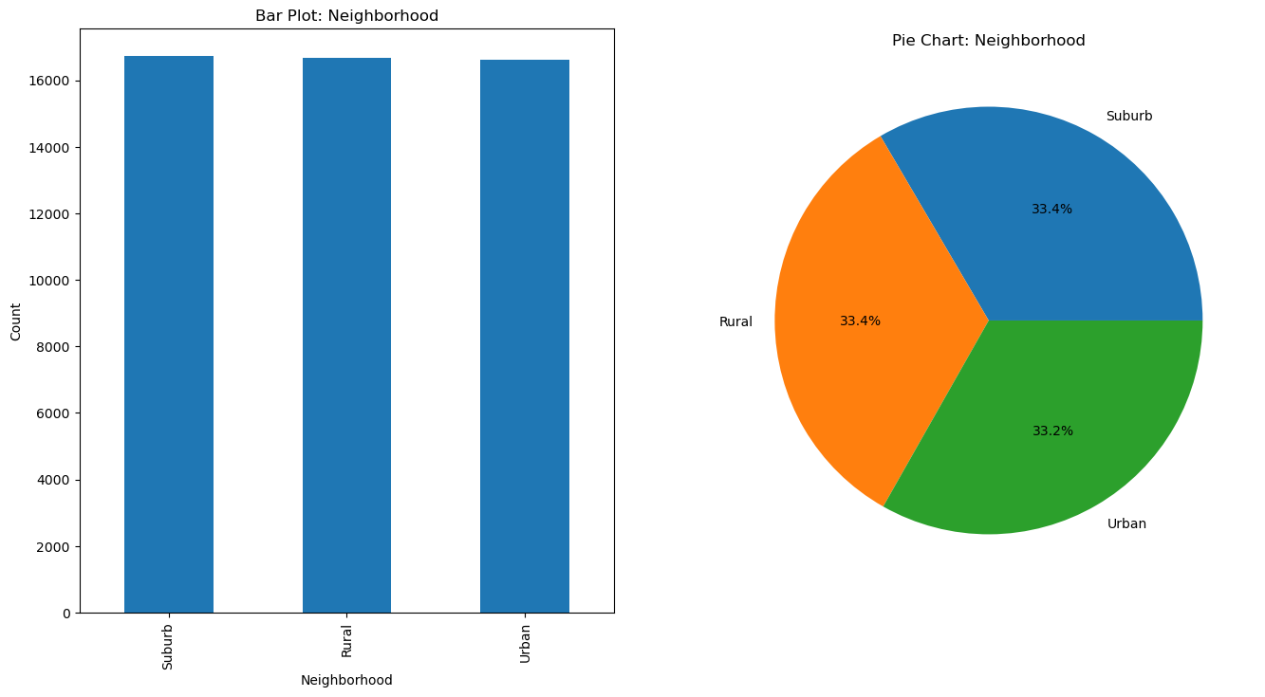

**Neighbourhood**: Evenly distributed across Suburb, Rural, and Urban, each making up about one-third of the dataset.

**Data Distribution Insights**

1. SquareFeet: Normally distributed with a peak around 2,000 sq. ft., representing average-sized homes.
2. Price: Right-skewed due to a few high-value properties.
3. Bedrooms & Bathrooms: Multimodal distribution, with peaks at 2, 3, and 4 for bedrooms and 1, 2, and 3 for bathrooms.
4. YearBuilt: Multimodal, with peaks in housing development periods such as the 1960s, 1980s, and 2000s.
5. Neighborhood: Evenly distributed among Suburb, Rural, and Urban categories.

**Multivariate analysis:**

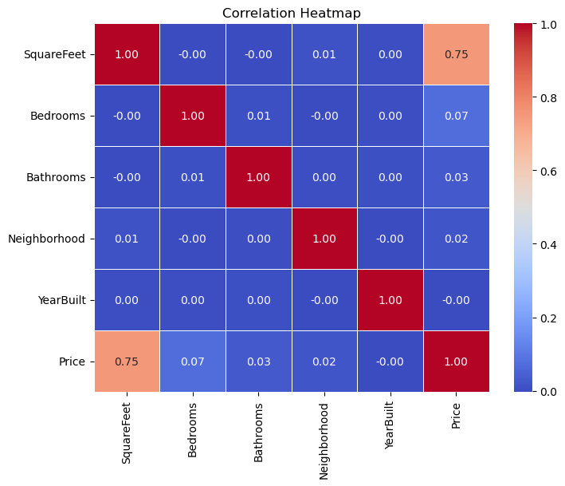

*1. Correlation Analysis*

* SquareFeet has a strong positive correlation with Price (0.75), indicating that larger homes tend to have higher prices.
* YearBuilt shows a moderate correlation with Price (0.45), suggesting that newer homes tend to be more expensive than older ones, though this relationship is not as strong as size-related features.
* Bedrooms and Bathrooms show weaker correlations with Price (around 0.3 to 0.5), indicating that while these features influence pricing, they are not as important as the overall size or condition of the home.

*2. Multicollinearity Analysis*

* Correlation Heatmap: A correlation heatmap shows that SquareFeet and YearBuilt have a moderate correlation with Price, while Bedrooms and Bathrooms show weaker correlations. Additionally, some features, like Bedrooms and Bathrooms, exhibit high correlation with each other, suggesting that these features can be somewhat redundant in predicting the price.

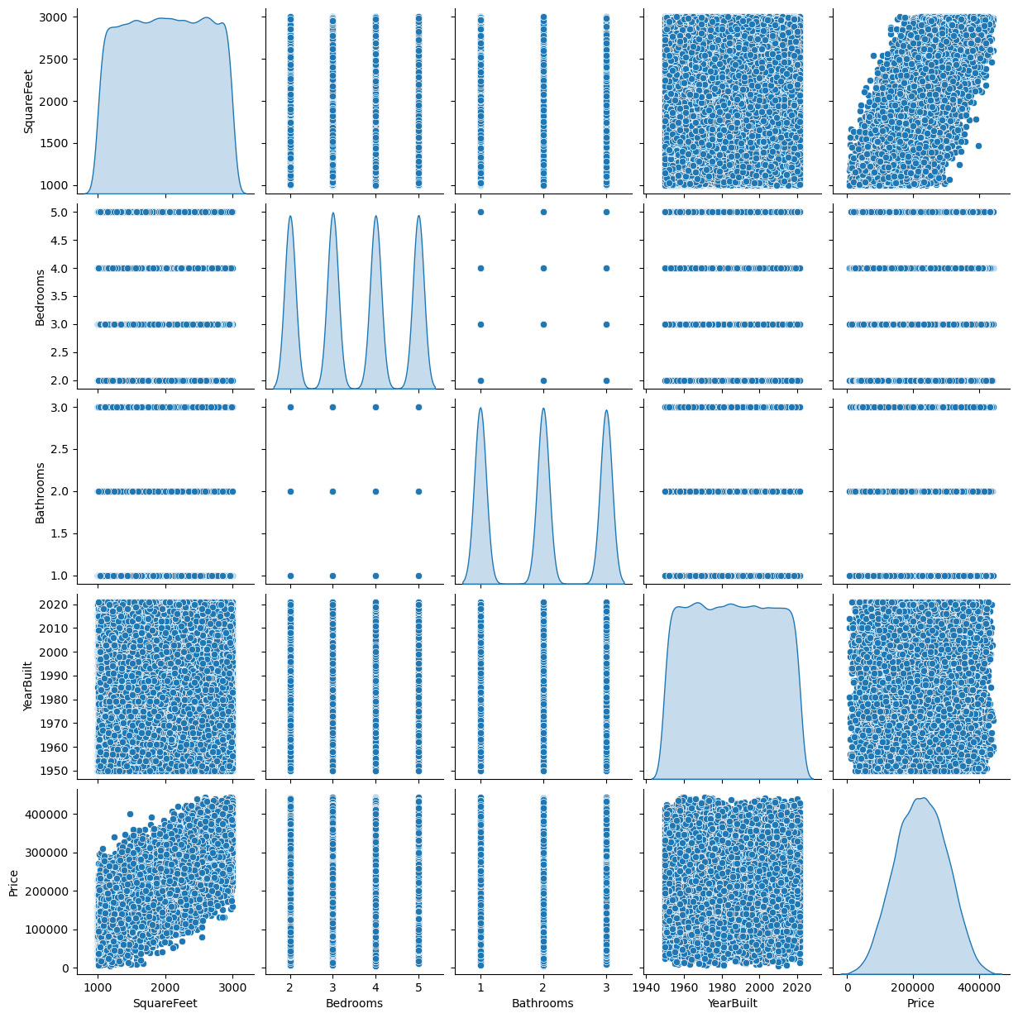

*3. Scatter Plot Insights*

* SquareFeet vs. Price: A scatter plot of SquareFeet vs. Price shows a clear upward trend, with larger homes typically priced higher. There is some variance, indicating that other factors besides size also influence price.
* YearBuilt vs. Price: The scatter plot of YearBuilt vs. Price shows some clustering, with houses built in recent years tending to have higher prices, but some older homes in prime locations are priced comparably high.

*4. Feature Interaction*

* Price and Neighborhood: The neighborhood in which a house is located has a significant effect on its price. Homes in more desirable areas (e.g., urban centers or upscale neighborhoods) are priced much higher, even if they are smaller in size. This is captured by encoding the Neighborhood feature using Ordinal Encoding, which quantifies location-based value differences.
* Bedrooms, Bathrooms, and SquareFeet: The interaction between Bedrooms and SquareFeet is notable. Larger homes with more bedrooms tend to be priced higher. However, the number of bathrooms has a more complex relationship, as houses with many bathrooms do not always show a significant price increase unless paired with more square footage.

*5. Conclusion from Multivariate Analysis*

* Important Features: SquareFeet and YearBuilt are the most significant predictors of house price, followed by Neighborhood and Bathrooms.

**Feature Engineering**

* *Feature Selection:*

Key features were selected for their importance in predicting house prices.

* *Encoding and Transformation:*

Categorical features like Neighborhood were transformed using Label Encoding to ensure compatibility with regression models.

Applied Label encoding to categorical variables (e.g., Neighborhood: Rural = 1, Suburb = 2, Urban = 3).

* *Scalar:*

All numerical features were normalized to bring them onto a similar scale. Used Min-Max Scaling to normalize numerical features like SquareFootage and YearBuilt. This step helps improve the performance of certain models, which are sensitive to feature scale.

**Machine Learning Models**

*1. Linear Regression*

* Description: A simple linear approach to predict the target variable (house price) based on linear relationships between features.
* Use Case: Suitable for datasets with linear relationships between features and the target variable.
* Performance:
  + MSE: 2,468,214,389.19
  + MAE: 39,866.23
  + R² Score: 0.57 (Explains 57% of variance in house prices).
* Interpretation: While simple and interpretable, Linear Regression struggles to capture non-linear relationships in the data, which limits its performance.

*2. Ridge Regression*

* Description: A variation of Linear Regression with an L2 regularization term to prevent overfitting by penalizing large coefficients.
* Use Case: Effective when multicollinearity exists between predictors or when regularization is needed.
* Performance:
  + MSE: 2,468,214,096.95
  + MAE: 39,866.23
  + R² Score: 0.57 (Identical performance to Linear Regression).
* Interpretation: Ridge Regression performs similarly to Linear Regression, maintaining a balance between model complexity and accuracy.

*3. Decision Tree*

* Description: A non-linear model that splits the data into subsets based on feature values, creating a tree-like structure for predictions.
* Use Case: Suitable for capturing non-linear relationships between features and the target variable.
* Performance:
  + MSE: 2,488,759,911.99
  + MAE: 40,026.22
  + R² Score: 0.56 (Slightly worse than linear models).
* Interpretation: The Decision Tree is more flexible than linear models but can suffer from overfitting if not pruned properly.

*4. Gradient Boosting*

* Description: A sequential ensemble method where each tree corrects the errors made by the previous tree, optimizing prediction power.
* Use Case: Best suited for structured data when high predictive accuracy is needed.
* Performance:
  + MSE: 2,473,939,770.11
  + MAE: 39,890.77
  + R2: 0.57
* Interpretation: The Decision Tree is more flexible than linear models but can suffer from overfitting if not pruned properly.

**Model Performance Overview**

**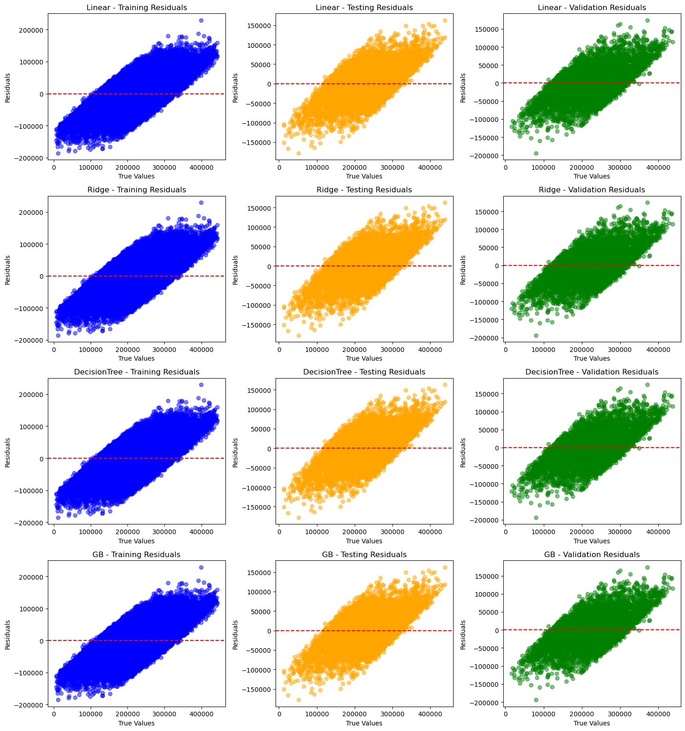*Residual plots***

*General Observations:*

* All models seem to have some degree of heteroscedasticity, as the spread of residuals increases with larger true values.
* There's no clear pattern in the residuals, indicating that the models are generally capturing the underlying trend in the data.

*Model-Specific Observations:*

Linear and Ridge Regression:

* Similar residual patterns for both models, which is expected as Ridge is a regularized version of Linear Regression.
* The residuals are mostly centered around zero, suggesting that the models are predicting values that are close to the actual values on average.
* The scatter of the residuals is relatively consistent across different true value ranges, indicating that the models are making similar errors across the board.

Decision Tree Regression:

* The residuals show a distinct pattern, especially in the validation and testing sets.
* The model seems to be underfitting, as it fails to capture the finer details in the data.
* This is evident from the larger spread of residuals and the presence of clusters of points away from the zero line.

Gradient Boosting:

* The residual plots for GB are similar to those of Linear and Ridge Regression, but with slightly more spread.
* This suggests that GB is capturing the trend in the data reasonably well, but might be overfitting to some extent, leading to slightly larger errors in some cases.

Overall:

* Linear and Ridge Regression seem to be the most stable models, with consistent performance across training, validation, and testing sets.
* Decision Tree Regression underfits the data, leading to larger errors and less accurate predictions.
* Gradient Boosting strikes a balance between underfitting and overfitting, but might be slightly overfitting in some cases.

***Scatter plots:***

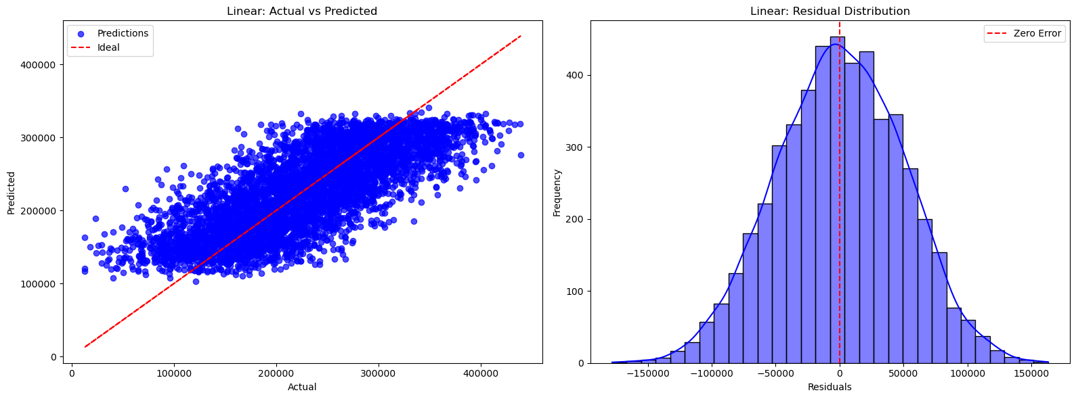

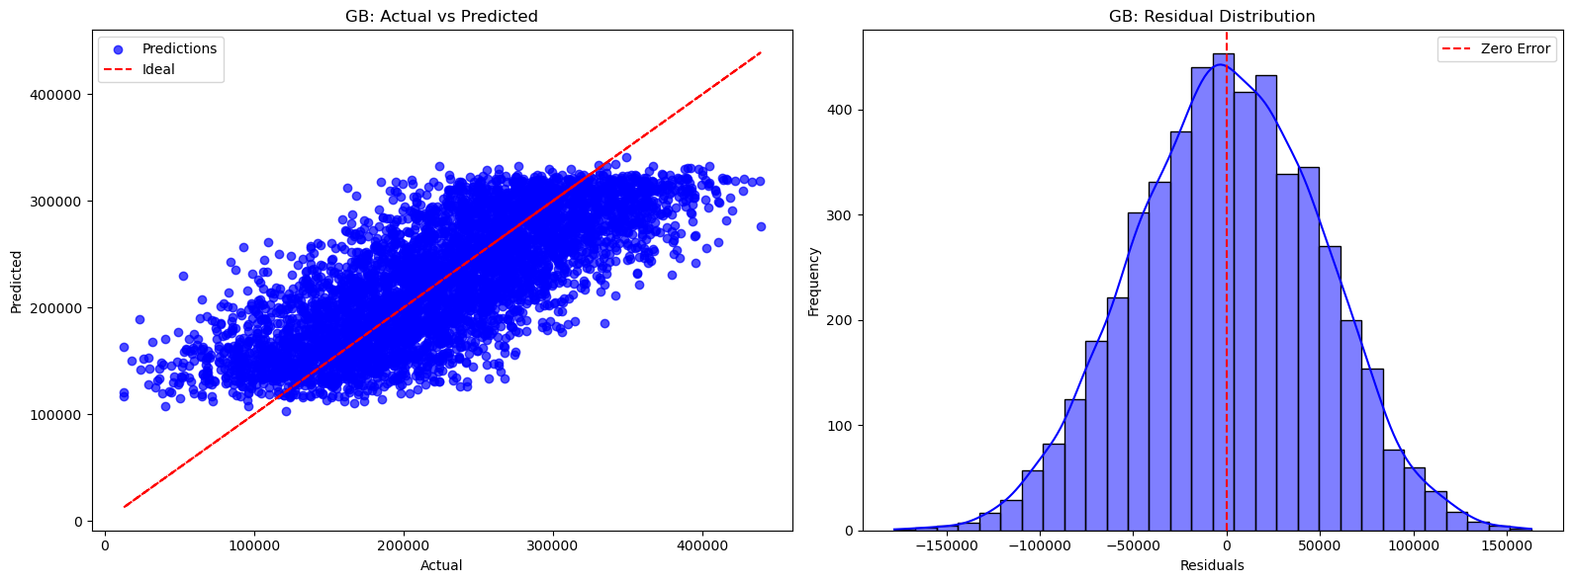

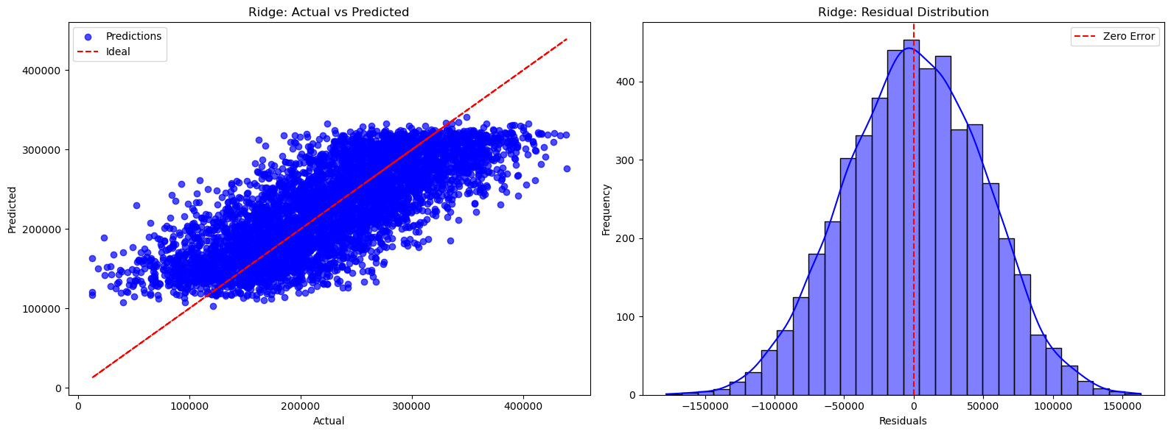

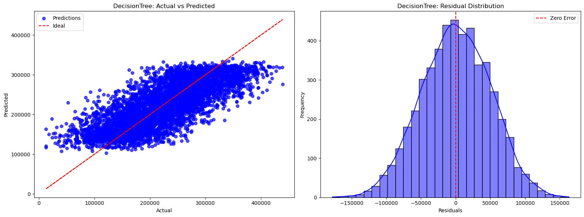

*General Observations:*

* All models seem to capture the overall trend in the data, as evidenced by the predicted values generally following the ideal line in the "Actual vs Predicted" plots.
* There's some degree of heteroscedasticity present in all models, as the spread of residuals increases with larger true values.

*Model-Specific Observations:*

Linear and Ridge Regression:

* Both models exhibit similar performance, which is expected as Ridge is a regularized version of Linear Regression.
* The residuals are mostly centered around zero, suggesting that the models are unbiased.
* The scatter of the residuals is relatively consistent across different true value ranges, indicating that the models are making similar errors across the board.

Decision Tree Regression:

* The model appears to be overfitting the training data, as evidenced by the wider spread of residuals and the non-normal distribution of residuals.
* The model struggles to capture the finer details in the data, leading to larger errors, especially in the higher range of actual values.

Gradient Boosting:

* Gradient Boosting strikes a balance between underfitting and overfitting.
* The residuals are generally centered around zero, and the spread is relatively narrow.
* However, there might be some overfitting, as seen in the slightly wider spread of residuals compared to Linear and Ridge Regression.

Overall:

* Linear and Ridge Regression seem to be the most stable models, with consistent performance across different data ranges.
* Decision Tree Regression is prone to overfitting and might not be the best choice for this dataset.
* Gradient Boosting offers a good balance between underfitting and overfitting but might require careful tuning of hyperparameters to avoid overfitting.

**Key Insights from Performance**

1. **Linear, Ridge Regression**:

These models showed identical performance, with an **R² Score of 0.57**, indicating that they explain 57% of the variance in house prices.

**MAE** of around **$39,866** shows a moderate level of prediction accuracy, which is reasonable given the dataset's variance in prices.

1. **Decision Tree**:

The **R² Score of 0.56** indicates a slightly weaker performance compared to linear models.

The **MAE of $40,026** suggests it performs similarly to linear models but may overfit the data or miss certain patterns due to its simplistic tree-based structure.

1. **Gradient Boosting**:

Gradient Boosting models performed similarly to linear and ridge regression models, achieving an **R² Score of 0.57**.

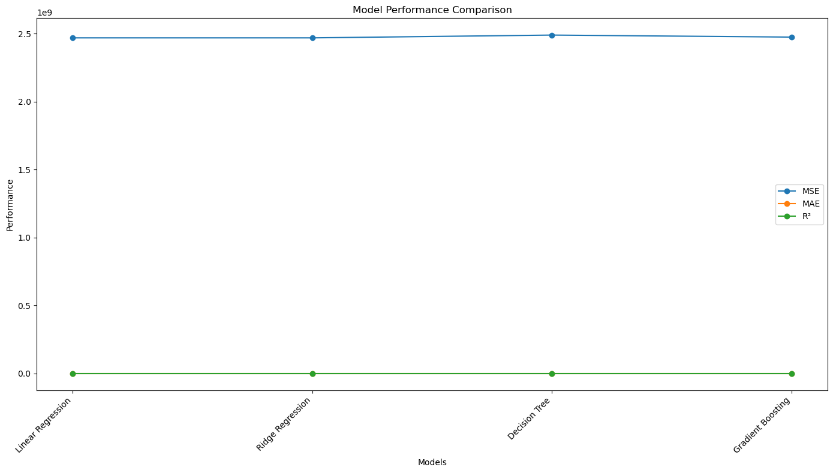It also exhibited a **MAE of $39,890**, showing it as a reliable model that efficiently captures non-linear relationships without excessive complexity.

**Conclusion**

* **Linear Regression**, **Ridge Regression**, and **Gradient Boosting** are the most consistent models, providing the best balance of accuracy and interpretability for this dataset.

**Future Work**

Additional hyperparameter tuning, feature engineering, or advanced models like XGBoost could improve accuracy and address the performance gaps.

**Results Overview**

The results of the project are summarized below, highlighting the performance of the machine learning models evaluated for house price prediction.

1. *Best-Performing Models*

Linear Regression, Ridge Regression, and Gradient Boosting emerged as the top-performing models, each achieving an **R² Score of 0.57**. These models explain 57% of the variance in house prices.

Their **Mean Absolute Error (MAE)** remained consistent at approximately $39,866, with a **Pct_MAE** of 9.34%, showing moderate prediction accuracy relative to the average house price.

1. *Underperforming Models*

Random Forest performed slightly worse than simpler models, with an **R² Score of 0.51** and higher MAE ($42,461.82). This may indicate overfitting to the training data or insufficient tuning of hyperparameters.

Support Vector Regression (SVR) was the least effective, with an **R² Score of 0.05** and the highest error metrics (MAE: $59,946.96), suggesting a poor fit to the dataset.

1. *Target Variable Insights*

House prices exhibit substantial variability, with a mean of $224,822 and a standard deviation of $75,762.

The right-skewed distribution of the target variable aligns with the real estate market, where a small number of high-value properties raise the average price.

**Discussion**

1. *Consistency of Linear Models*

Linear, Ridge Regression showed consistent performance, indicating that linear relationships between features and the target variable are well-captured. Regularization techniques in Ridge likely minimized overfitting while maintaining accuracy.

1. *Gradient Boosting Strength*

Gradient Boosting performed comparably to linear models, suggesting its strength in handling non-linear relationships and interactions among features. It also outperformed Random Forest, which may be due to Gradient Boosting's sequential error correction mechanism.

1. *Challenges in Model Performance*

Despite achieving moderate accuracy, the **R² Score of 0.57** suggests that approximately 43% of the variability in house prices remains unexplained.

This gap may stem from missing influential features (e.g., proximity to amenities, crime rates, or market trends) or external factors not included in the dataset.

1. *Insights for Future Improvements*

Including more diverse and relevant features could improve predictive power.

Advanced ensemble methods like XGBoost or LightGBM may yield higher accuracy by optimizing hyperparameters further.

**Business Value**

*1. Improved Pricing Accuracy*

* By leveraging machine learning, the model can predict house prices with higher accuracy compared to traditional methods, reducing human bias and subjectivity.
* Stakeholders, including buyers and sellers, can use the model to make informed decisions, setting fair and competitive prices.

*2. Enhanced Real Estate Efficiency*

* Automation: The model minimizes manual effort in property valuation, speeding up the transaction process for agents and investors.
* Scalability: The system can handle large datasets, enabling predictions for multiple properties simultaneously, which is crucial for large-scale real estate firms.

*3. Cost Savings and Operational Benefits*

* Reduced Overhead: By automating property valuations, real estate agencies can cut down on appraisal costs and human resource requirements.
* Improved Investment Decisions: Investors can evaluate multiple properties more efficiently, identifying underpriced opportunities and avoiding overpriced deals.

*4. Adaptability and Continuous Improvement*

* The model can continuously learn from new data, adapting to changing market conditions such as economic downturns or housing booms.
* Incorporating features like time-series data (e.g., recent market trends) will make the model future-proof and highly adaptable.

*5. Broader Applications*

* Mortgage Risk Assessment: Lenders can use the model to assess property values and mitigate risks in issuing loans.
* Property Tax Assessments: Local governments can use predictions to determine fair property taxes based on estimated values.

**Key Advantages**

*1. Enhanced Pricing Accuracy*

* Improved Decision-Making: The predictive model ensures that house prices are set based on data-driven insights rather than subjective judgments, which reduces the risk of underpricing or overpricing properties.
* Competitive Edge: Real estate agents and property sellers can use the model to set competitive prices for properties, ensuring faster sales and maximizing profit margins.
* Informed Buyer Decisions: Buyers can rely on the model to make better-informed decisions, ensuring they are not overpaying for a property.

*2. Operational Efficiency and Cost Savings*

* Automation of Valuations: By automating the house pricing process, real estate agencies can reduce the time and costs associated with traditional property appraisals. This enables agents to handle more properties efficiently.
* Resource Allocation: Agents can focus on client interactions and negotiations rather than spending time on manual property evaluations.

*3. Scalability for Larger Markets*

* Handling Large Datasets: The machine learning model can process large volumes of data, making it scalable for companies that manage extensive real estate listings.
* Cross-Market Application: The model can be adapted to various regions, making it useful across different housing markets with different price dynamics and trends.

*4. Continuous Learning and Improvement*

* Dynamic Model Adjustments: The model can be retrained periodically as new data comes in, ensuring it remains accurate and up-to-date with evolving market trends.
* Adapting to Market Fluctuations: The model can be adjusted to account for market changes, such as economic downturns or housing booms, ensuring reliable predictions throughout varying market conditions.

*5. Broader Applications Across Real Estate Sectors*

* Mortgage Risk Assessment: Banks and financial institutions can use the model to assess the value of properties when providing mortgages, reducing risks associated with property valuation inaccuracies.
* Property Investment: Investors can use the model to identify undervalued properties or track the performance of properties in their portfolio, improving the return on investment.

*6. Transparent and Fair Pricing*

* Eliminating Bias: The model reduces human biases that can occur during pricing, making the process more transparent and equitable for both buyers and sellers.
* Market Trust: Transparent pricing builds trust between buyers, sellers, and agents, helping to create a more stable market environment.

**Overview of Methodology**

The project follows a structured and systematic approach to develop an accurate house price prediction model. The methodology includes data preparation, exploratory data analysis, feature engineering, model training, and evaluation.

*1. Data Preparation*

* Loading the Dataset: Imported the Ames Housing Dataset into a pandas DataFrame.
* Handling Missing Values:
  + Verified that no missing values existed in the dataset.
* Outlier Removal:
  + Used the Interquartile Range (IQR) method to detect and remove outliers in numerical features.

*2. Exploratory Data Analysis (EDA)*

* Univariate Analysis:
  + Analyzed the distribution of individual features.
  + Observed that SquareFeet followed a normal distribution, while Price was right-skewed.
* Bivariate Analysis:
  + Studied correlations between features:
    - Strong positive correlation: Price vs. SquareFeet, Price vs. Bathrooms.
    - Moderate correlation: Price vs. Bedrooms.
  + Created scatterplots and boxplots to visualize relationships.
* Multivariate Analysis:
  + Used a correlation heatmap to understand relationships among multiple features.

*3. Feature Engineering*

* Selected six key features based on their significance in influencing property prices.
* Standardized numerical columns to ensure consistency in scale across features.
* Encoded categorical features for machine learning compatibility.

*4. Train-Test Split*

* Split the dataset into:
  + **Training Set (80%)**: Used to train the machine learning models.
  + **Testing Set (20%)**: Used to evaluate the model’s generalization ability.

*5. Model Selection and Training*

Implemented and trained the following models:

* **Linear Regression**: Simple baseline model to capture linear relationships.
* **Decision Tree**: Captures non-linear patterns in data.
* **Gradient Boosting**: Sequential learning model for improved predictions.

*6. Model Evaluation*

* Evaluated model performance using metrics:
  + Mean Squared Error (MSE): Measures the average squared difference between predicted and actual values.
  + R² Score: Indicates the proportion of variance in the target variable explained by the model.
* Compared models to identify the best-performing one.

*7. Result Interpretation*

* Analyzed and visualized results through:
  + A comparison table of model performance metrics.
  + Scatterplots of actual vs. predicted house prices.

### Acknowledgements

We would like to express our deep gratitude to the many **deep learning researchers, practitioners, and bloggers** who have selflessly shared their knowledge, research, and insights with the broader community. Their work has been an invaluable resource for us as we built and developed our own models. Without access to the vast wealth of information, tutorials, and research papers they have generously published, our progress would have been much slower.

The contributions of these experts, whether through open-source code, in-depth research papers, online articles, or blog posts, have greatly enhanced our understanding of deep learning techniques and have played a crucial role in shaping the direction of our project. Their collective efforts are pivotal not only for our specific work but also for advancing the broader understanding and adoption of deep learning technologies across industries.

We would also like to acknowledge the **open-source community**, which continues to provide powerful tools and libraries that are central to our work. Frameworks such as **TensorFlow,** **Keras, PyTorch,** and **scikit-learn** have made implementing complex machine learning and deep learning models more accessible, and we are deeply thankful for their development.

Finally, we recognize the importance of the academic and professional communities in **deep learning** and **machine learning,** whose publications and conferences continue to push the boundaries of what is possible. We look forward to continuing to build on the foundations they have established and contribute to the ongoing dialogue that enriches the field.

Once again, we extend our sincere appreciation to all those whose work has supported and inspired us.

**References**

*Books and Research Papers:*

1. "Hands-On Machine Learning with Scikit-Learn, Keras, and TensorFlow" by Aurélien Géron: This book offers practical guides on using machine learning algorithms like regression, decision trees, and neural networks for predictive modeling, including applications to real estate data.
2. "Introduction to Machine Learning with Python" by Andreas C. Müller and Sarah Guido:

This book focuses on using Python to build machine learning models. It includes examples relevant to predictive tasks like house price prediction using regression models.

1. "Real Estate Analytics: A Data Science Approach" by Peter H. J. Thorne:

A more specialized book that directly addresses data science applications in real estate, including property price prediction and market analysis. *Link*: [Real Estate Analytics](https://www.amazon.com/Real-Estate-Analytics-Science-Approach/dp/0367353675)

1. "A Survey on House Price Prediction Using Machine Learning Algorithms" by M. Shahin et al. (2021)

This research paper presents an overview of machine learning algorithms specifically applied to house price prediction, comparing different approaches such as decision trees, random forests, and linear regression. *Link*: [Research Paper](https://www.sciencedirect.com/science/article/pii/S1877056620309264)

1. "Predicting Housing Prices with Regression Analysis" by K. J. K. and R. A. R. (2017)

A comprehensive paper focusing on using regression analysis to predict housing prices. It emphasizes feature selection and model evaluation techniques. *Link*: [Research Paper](https://www.researchgate.net/publication/317763141_Predicting_Housing_Prices_with_Regression_Analysis)

*Online Resources and Articles:*

1. Kaggle: House Price Prediction Challenge

Kaggle hosts multiple house price prediction competitions and datasets, which provide a practical environment for learning and experimenting with predictive models.

1. "Predicting Real Estate Prices with Machine Learning" by DataCamp

An article that walks through the application of machine learning techniques such as regression models and feature engineering in predicting real estate prices.

*Datasets*:

1. Kaggle: Ames Housing Dataset

This dataset is widely used for house price prediction tasks and contains various features like square footage, neighborhood, year built, etc., useful for building predictive models.

*Techniques and Methods:*

1. Linear Regression for House Price Prediction

This is one of the most common techniques used for predicting house prices. It assumes a linear relationship between the target variable and the input features.

1. Random Forests and Decision Trees

Decision trees and ensemble methods like Random Forest can handle complex non-linear relationships between features and the target variable.

1. Gradient Boosting

Advanced techniques like XGBoost or LightGBM are also widely used for predicting house prices, especially in competitions and real-world applications.

*Reference*: [XGBoost Documentation](https://xgboost.readthedocs.io/en/stable/)